Jaguar Intramural Spring Football

This two-week program will work football skills lead by our SSMS football staff. Participants will also take part in a flag football tournament.

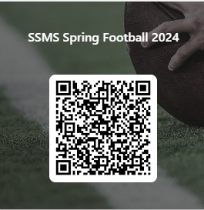

Link : https://forms.office.com/r/X7prqDPgQ9
Program Dates: May 7th, 9th, 14th, 16^{th.}
Program Days- Tuesday’s- Thursdays for two weeks.
Program Times: 3:00 to 4:30 PM
Contact: Coach Boggess tboggess@pasco.k12.fl.us

