Seven Springs Middle School
Volleyball Tryouts
2023-2024

Monday, August 14th: 8th Graders
Tuesday, August 15th: 7th Graders
Wednesday, August 16th: 6th Graders
Thursday, August 17th & Friday, August 18th: Final Cuts

Coaches will post a list of players that have made first cuts the morning following their tryout date.

Players that have made first cuts will continue to try out on Thursday, 8/17 and Friday, 8/18.
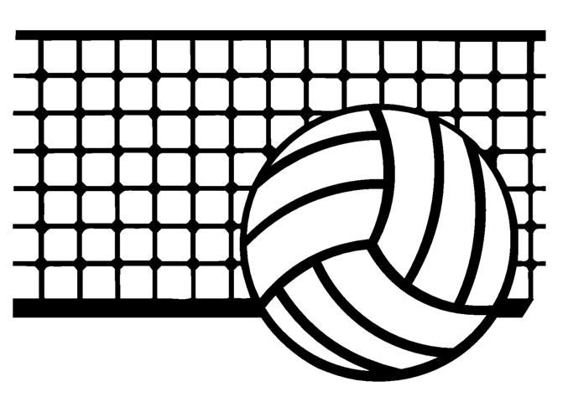
See Coach Bruno (room 213) or Coach Rulison-Lange(gym) if you have any questions

Athletic paperwork must be completed, signed, and submitted BEFORE your student can participate in tryouts. All paperwork will be uploaded to the school portal.
Please email Coach Gigantelli with paperwork questions.
dgigante@pasco.k12.fl.us

