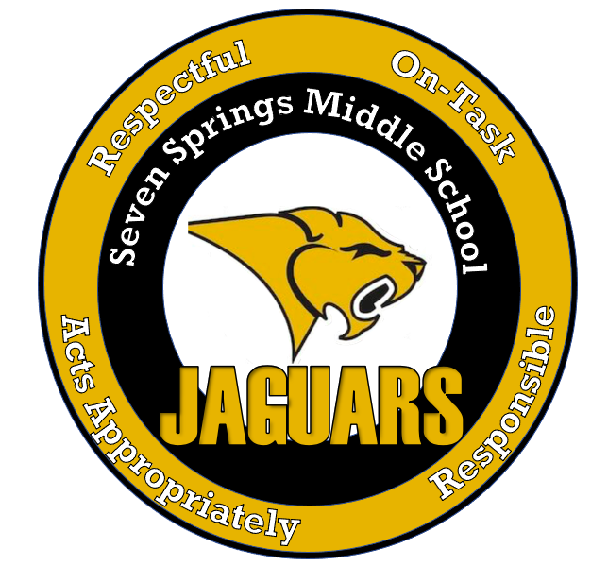

SEVEN SPRINGS MIDDLE SCHOOL

Jan., 2022-May, 2022

BELL SCHEDULES

**Regular Schedule**

1st Bell: 8:31AM

Warning Bell: 8:33AM

Period 1 8:36AM to 9:31AM

Period 2 9:35AM to 10:26AM

Period 3 10:30AM to 11:21AM

Period 4 11:25AM to 12:16PM

Period 5 12:20PM to 1:11PM

Period 6 1:15PM to 2:06PM

Period 7 2:10PM to 3:01PM

**Activity & Pep Rally Schedule**

1st Bell: 8:31AM

Warning Bell: 8:33AM

Period 1 8:36AM to 9:16AM

Period 2 9:20AM to 10:00AM

Period 3 10:04AM to 10:44AM

Period 4 10:48AM to 11:28AM

Period 5 11:32AM to 12:12PM

Period 6 12:16PM to 12:56PM

Period 7 1:00PM to 1:40PM

Activity 1:44PM to 3:01PM

**Jaguar Lunch and Study Hall/Intervention**

Students report to Study Hall/Intervention Class prior to attending Lunch.

**Early Release Days**

9/8/21

10/6/21

11/10/21

12/8/21

1/12/22

2/2/22

3/2/22

4/13/22

**Early Release Schedule**

1st Bell: 8:31AM

Warning Bell: 8:33AM

Period 1 8:36AM to 9:13AM

Period 2 9:17AM to 9:51AM

Period 3 9:55AM to 10:29AM

Period 4 10:33AM to 11:07AM

Period 5 11:11AM to 11:45AM

Period 6 11:49AM to 12:23PM

Period 7 12:27PM to 1:01PM



SEVEN SPRINGS MIDDLE SCHOOL

Jan., 2022-May, 2022

REGULAR BELL SCHEDULE

**Regular Schedule**

1st Bell: 8:31AM

Warning Bell: 8:33AM

Period 1 8:36AM to 9:31AM

Period 2 9:35AM to 10:26AM

Period 3 10:30AM to 11:21AM

Period 4 11:25AM to 12:16PM

Period 5 12:20PM to 1:11PM

Period 6 1:15PM to 2:06PM

Period 7 2:10PM to 3:01PM

**Lunch A Lunch B Lunch C**

Study Hall/Intervention: Study Hall/Intervention: Study Hall/Intervention:

10:30AM to 10:51AM 11:25AM to 11:46AM 12:20PM to 12:41PM

Lunch: Lunch: Lunch:

10:51AM to 11:21AM 11:46AM to 12:16PM 12:41PM to 1:11PM

*Students report to Study Hall/Intervention Class prior to attending Lunch.



SEVEN SPRINGS MIDDLE SCHOOL

Jan., 2022-May, 2022

ACTIVITY & PEP RALLY BELL SCHEDULE

**Activity & Pep Rally Schedule**

1st Bell: 8:31AM

Warning Bell: 8:33AM

Period 1 8:36AM to 9:16AM

Period 2 9:20AM to 10:00AM

Period 3 10:04AM to 10:44AM

Period 4 10:48AM to 11:28AM

Period 5 11:32AM to 12:12PM

Period 6 12:16PM to 12:56PM

Period 7 1:00PM to 1:40PM

Activity 1:44PM to 3:01PM

**Lunch A Lunch B Lunch C**

Lunch: Lunch: Lunch:

10:04AM to 10:44AM 10:48AM to 11:28AM 11:32AM to 12:12PM

*Students please drop off your backpacks to your class prior to attending Lunch.



SEVEN SPRINGS MIDDLE SCHOOL

Jan., 2022-May, 2022

EARLY RELEASE BELL SCHEDULE

**Early Release Schedule**

1ST Bell: 8:31AM

Warning Bell: 8:33AM

Period 1 8:36AM to 9:13AM

Period 2 9:17AM to 9:51AM

Period 3 9:55AM to 10:29AM

Period 4 10:33AM to 11:07AM

Period 5 11:11AM to 11:45AM

Period 6 11:49AM to 12:23PM

Period 7 12:27PM to 1:01PM

**Early Release Days**

9/8/21

10/6/21

11/10/21

12/8/21

1/12/22

2/2/22

3/2/22

4/13/22

**Lunch A Lunch B Lunch C**

Lunch: Lunch: Lunch:

9:55AM to 10:29AM 10:33AM to 11:07AM 11:11AM to 11:45AM

*Students please drop off your backpacks to your class prior to attending Lunch.